Ex.No. 15: AI-based Traffic Prediction for 5G Networks
Objective 1:
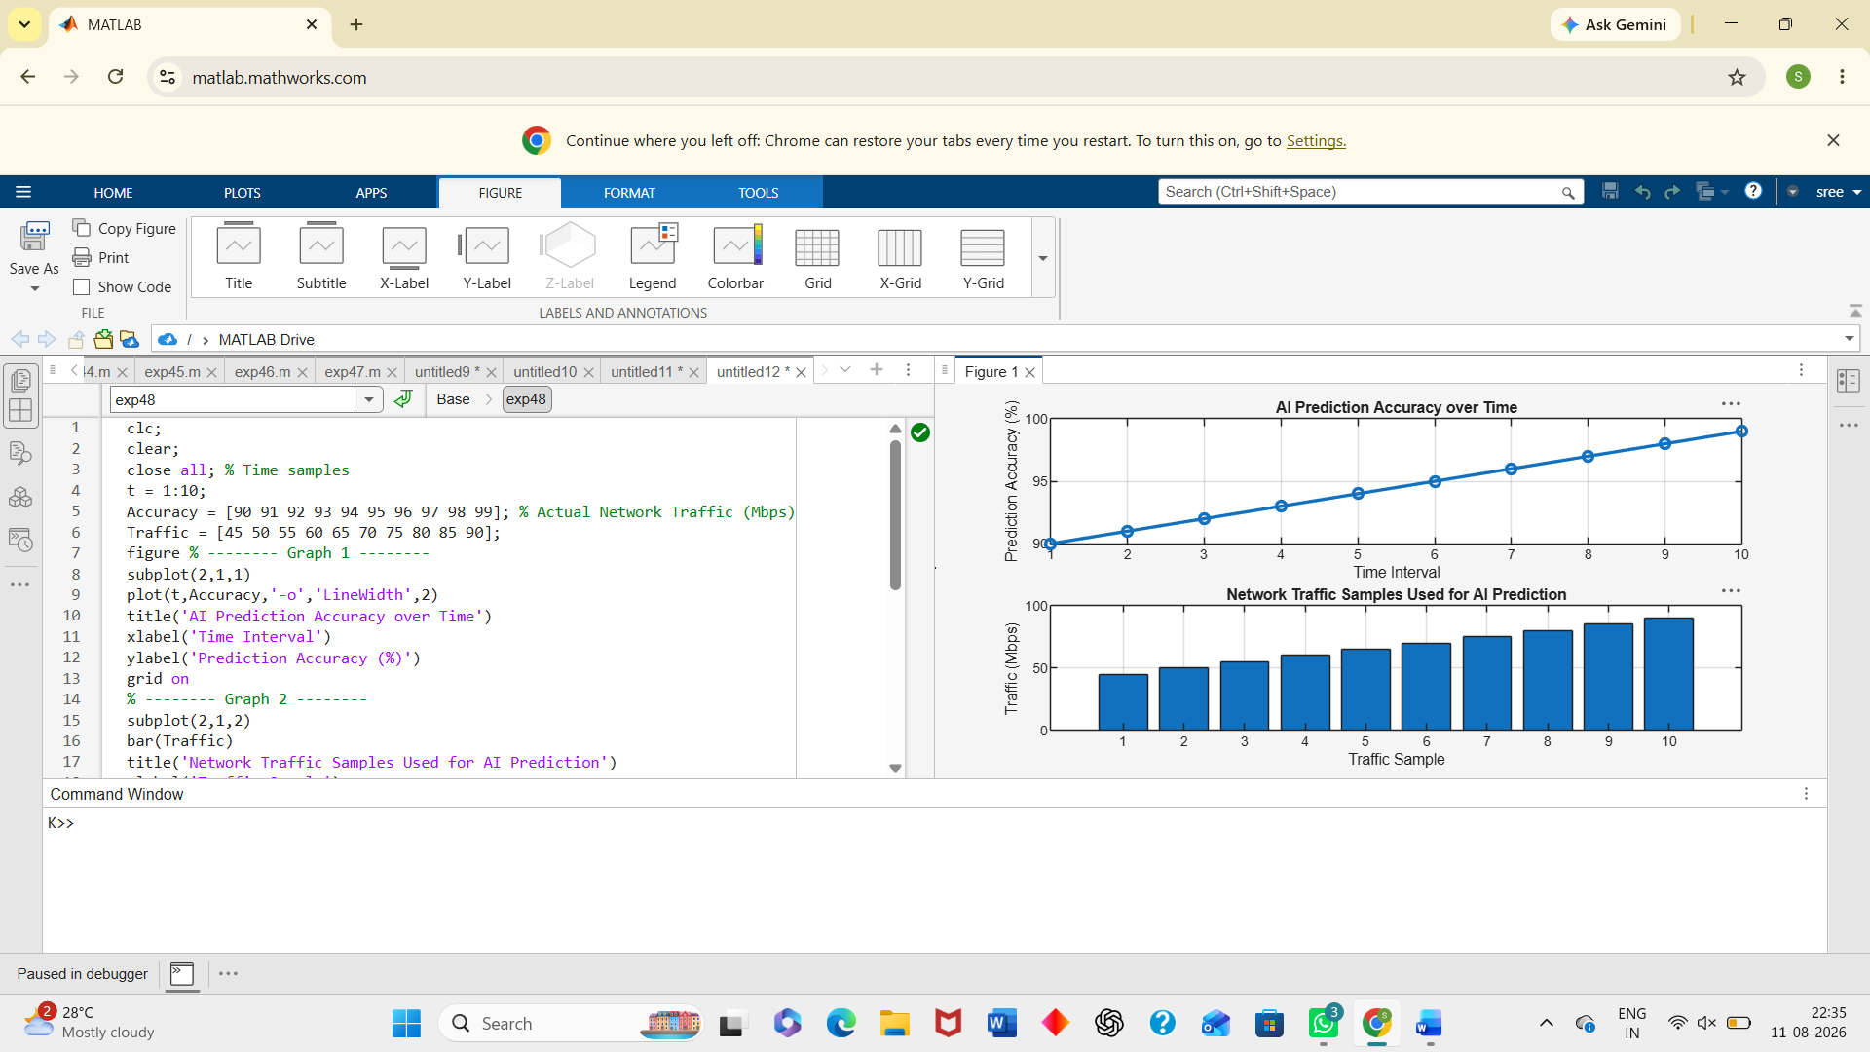
Objective 2:
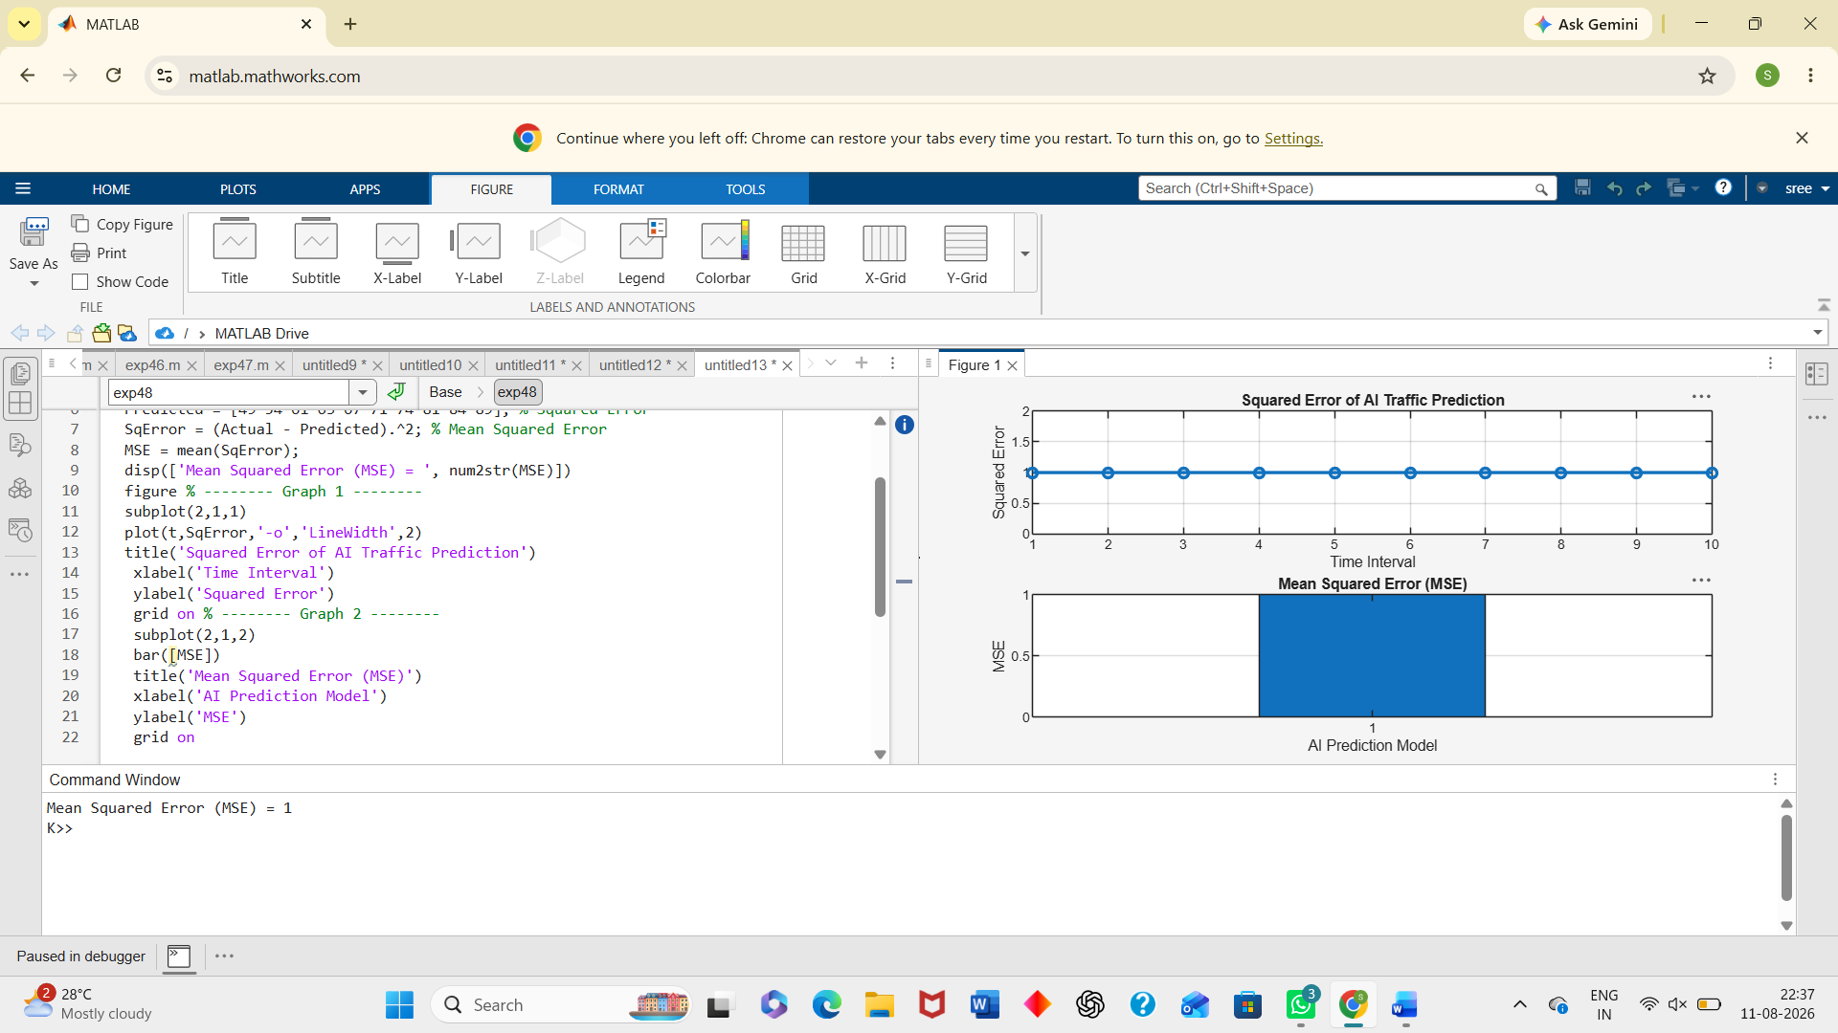
Objective 3:
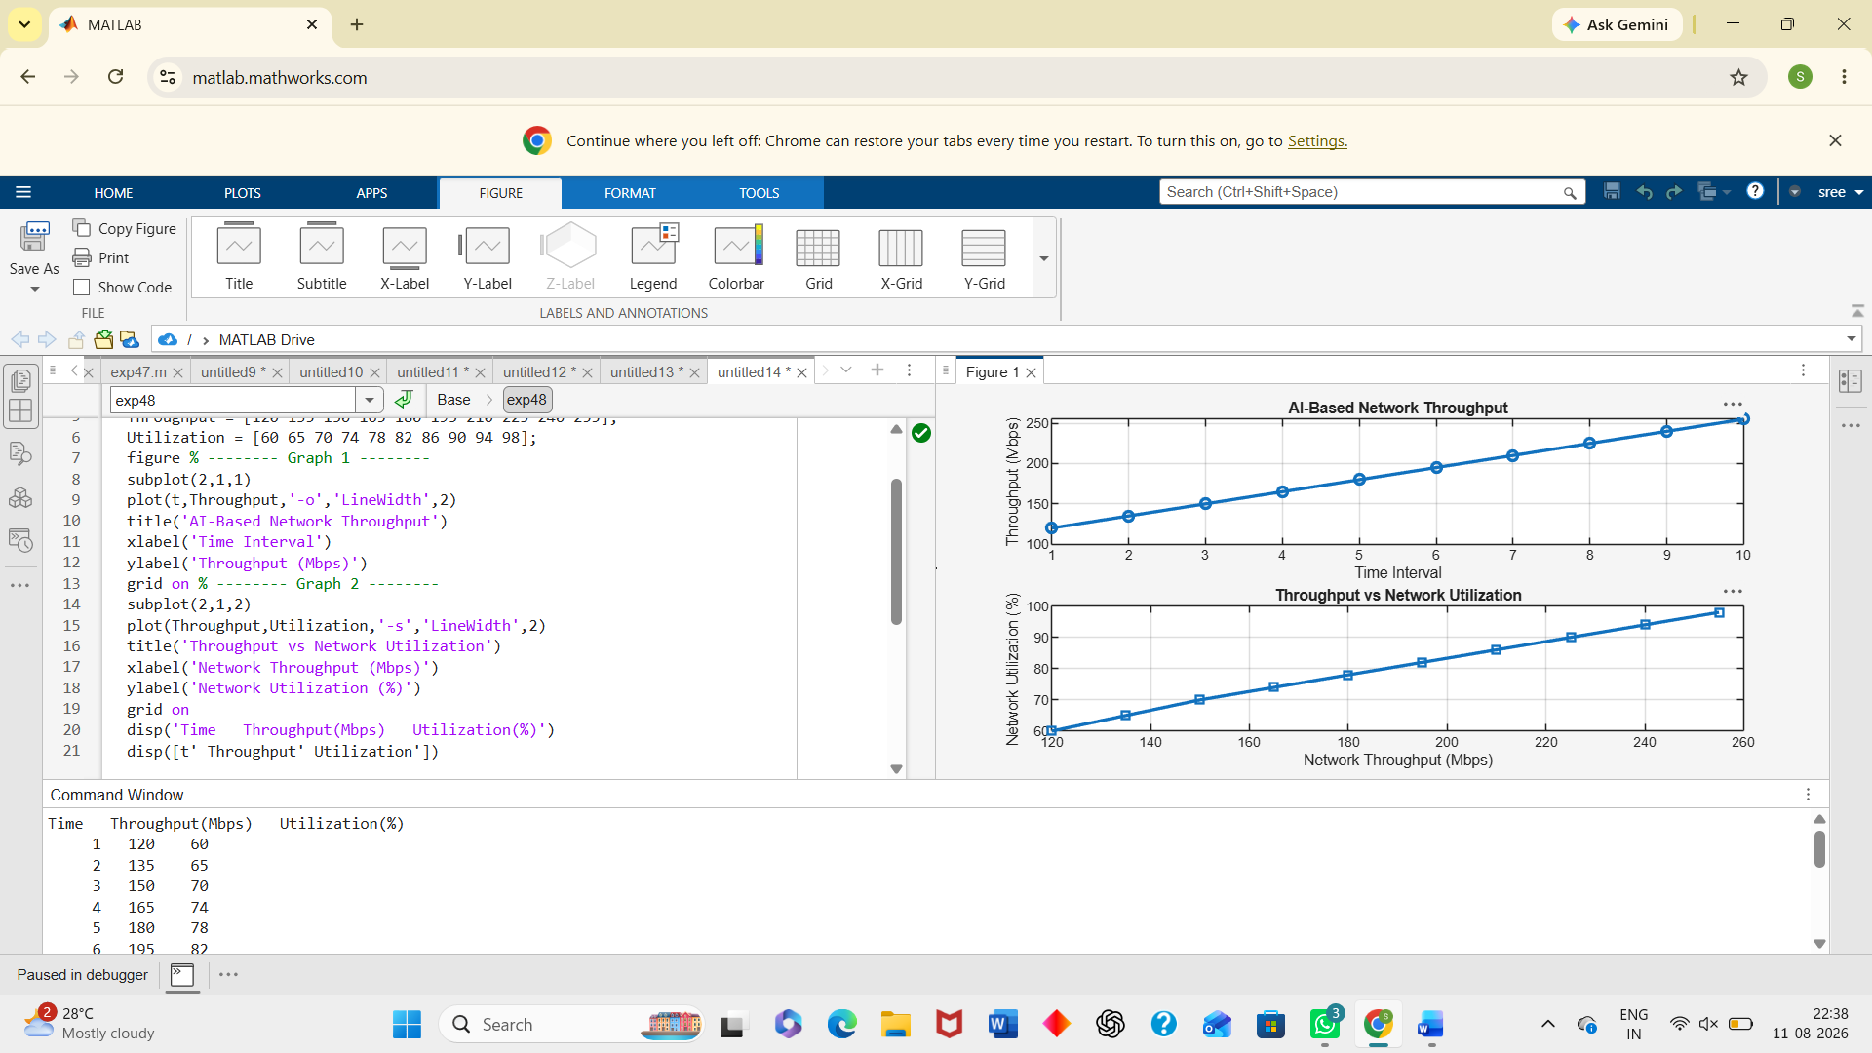
Result:
1. The AI-based traffic prediction model achieved high Prediction Accuracy (%), demonstrating its effectiveness in forecasting 5G network traffic patterns. 2. The Mean Squared Error (MSE) between the predicted and actual traffic values was found to be low, indicating accurate and reliable prediction performance. 3. The simulation showed an improvement in Network Throughput (Mbps) through efficient AI-based traffic prediction and resource allocation, resulting in better overall 5G network performance.

